SQL SHOW DATABASES and TABLES

🔍 Purpose
# Source: AI Source: Provided by: [Data Path: Persons Table -> ID Column: 1, Name_En Column: Motasem Essam] -> From: [ChatGPT] on [6/11/2026]
These commands are used to view all available databases and list all tables within a selected database. These are common administrative tasks when navigating your MySQL environment.

✅ Lesson Content

1. SHOW DATABASES
# Source: AI Source: Provided by: [Data Path: Persons Table -> ID Column: 1, Name_En Column: Motasem Essam] -> From: [ChatGPT] on [6/11/2026]
- This command shows all databases that the current user has permission to view.
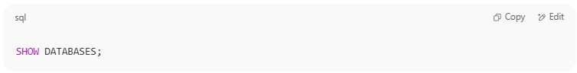
SHOW DATABASES;

👀 Example Output:
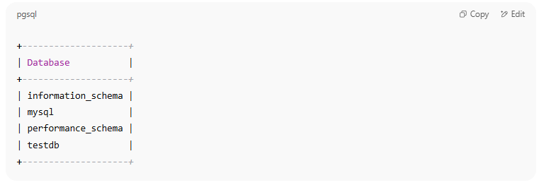
+--------------------+
| Database |
+--------------------+
| information_schema |
| mysql |
| performance_schema |
| testdb |
+--------------------+

2. USE database_name
# Source: AI Source: Provided by: [Data Path: Persons Table -> ID Column: 1, Name_En Column: Motasem Essam] -> From: [ChatGPT] on [6/11/2026]
- This command selects a database to work with.
- Switch between databases.
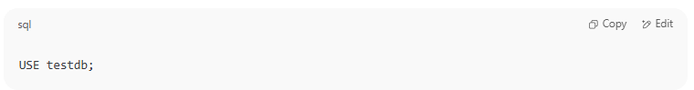
USE testdb;

3. SHOW TABLES
# Source: AI Source: Provided by: [Data Path: Persons Table -> ID Column: 1, Name_En Column: Motasem Essam] -> From: [ChatGPT] on [6/11/2026]
- After selecting a database, this command shows all the tables inside it.
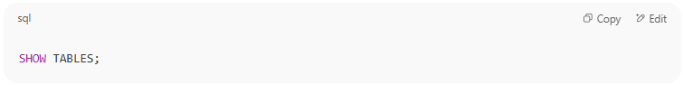
SHOW TABLES;

👀 Example Output:
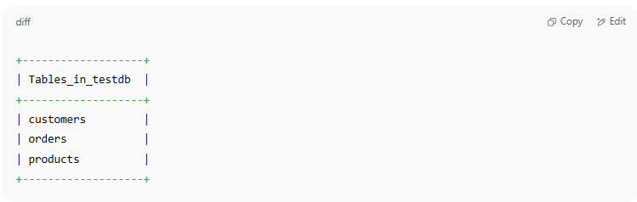
+-------------------+
| Tables_in_testdb |
+-------------------+
| customers |
| orders |
| products |
+-------------------+

🧠 Notes
# Source: AI Source: Provided by: [Data Path: Persons Table -> ID Column: 1, Name_En Column: Motasem Essam] -> From: [ChatGPT] on [6/11/2026]
- If you try SHOW TABLES without using a database first, you'll get an error.
- You must have the SHOW privilege on a database to list it.

🧪 Practice Example
# Source: AI Source: Provided by: [Data Path: Persons Table -> ID Column: 1, Name_En Column: Motasem Essam] -> From: [ChatGPT] on [6/11/2026]
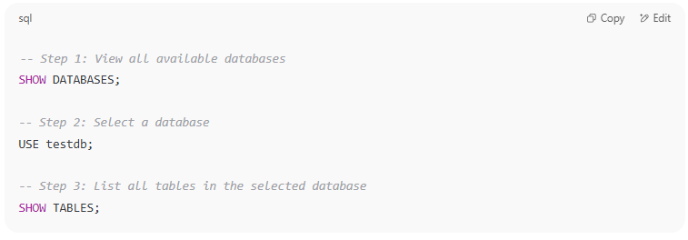
-- Step 1: View all available databases
SHOW DATABASES;

-- Step 2: Select a database
USE testdb;

-- Step 3: List all tables in the selected database
SHOW TABLES;

Would you like to continue with the next lesson: SHOW CREATE TABLE or DESCRIBE?

Example

prepared commands
# Source: ScreenShot Source: Provided by: [Persons Table -> ID Column: 1, Name_En Column: Motasem Essam] -> Tool: [Automation Table -> ID Column: 16, Name_En Column: Screen Capture] -> From [Operating System: Wampserver64 -> phpmyadmin] on [6/11/2026]
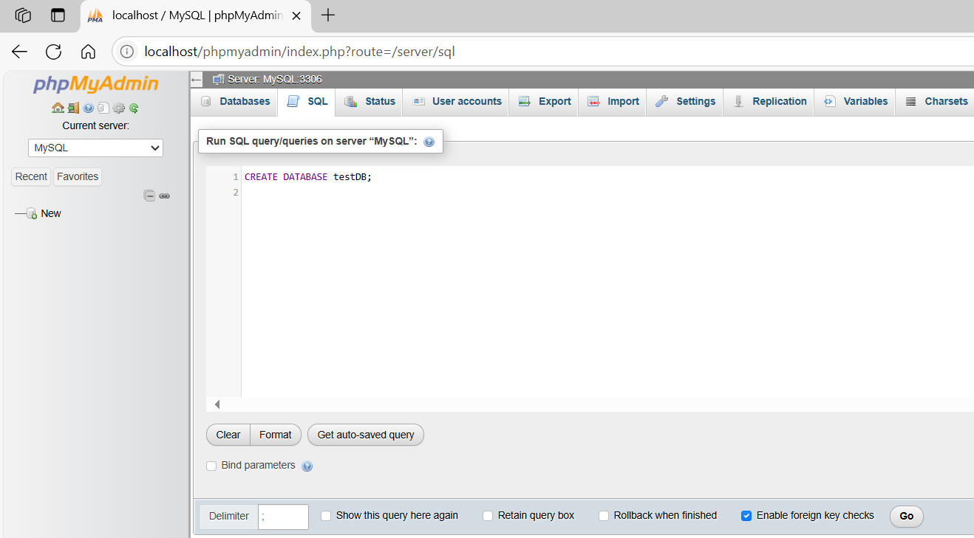
CREATE DATABASE testDB;
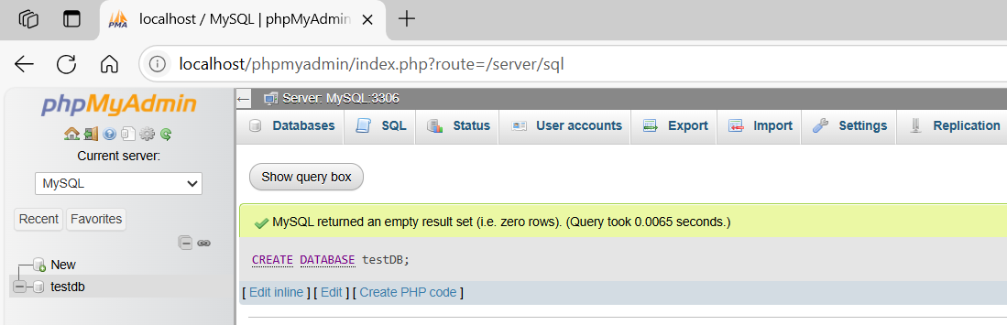

basic command - USE DATABASE
# Source: ScreenShot Source: Provided by: [Persons Table -> ID Column: 1, Name_En Column: Motasem Essam] -> Tool: [Automation Table -> ID Column: 16, Name_En Column: Screen Capture] -> From [Operating System: Wampserver64 -> phpmyadmin] on [6/11/2026]
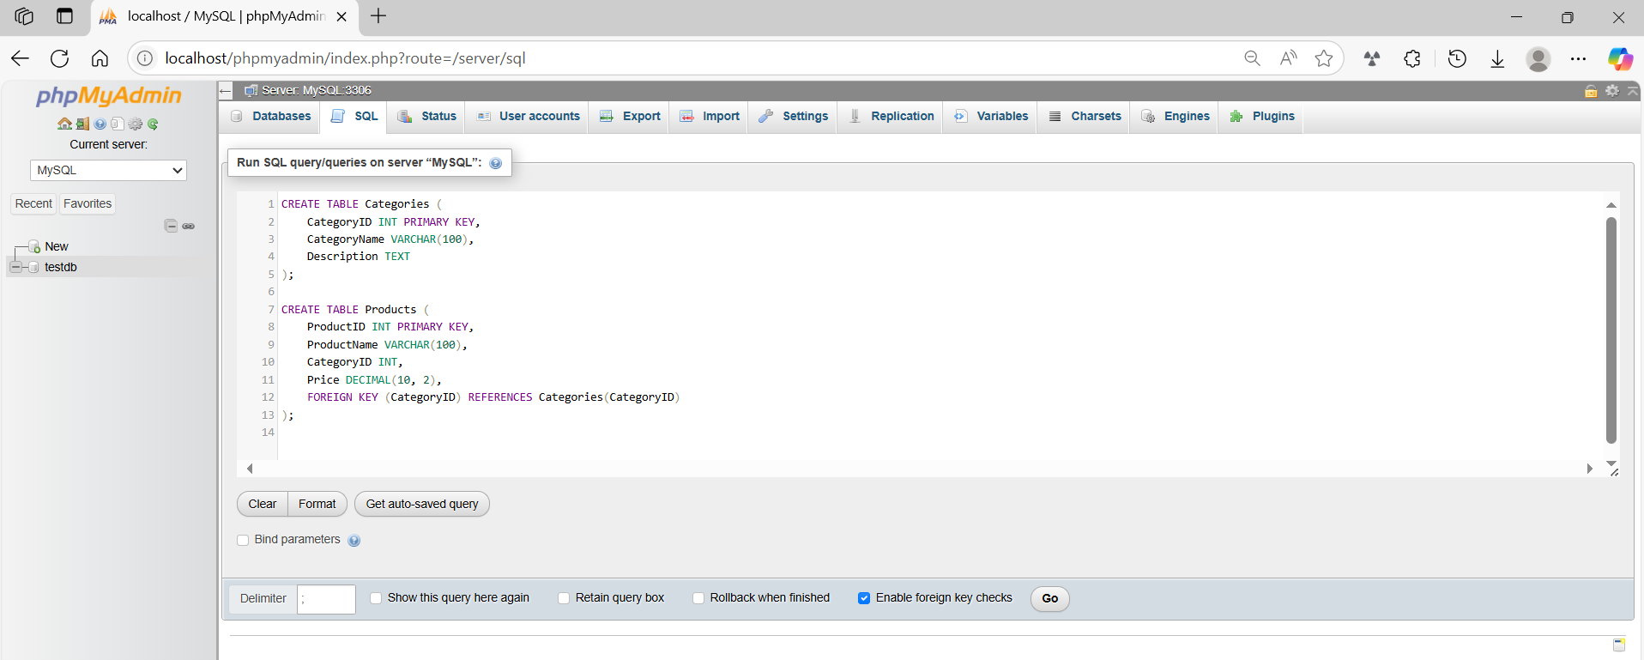

CREATE TABLE Categories (
CategoryID INT PRIMARY KEY,
CategoryName VARCHAR(100),
Description TEXT
);

CREATE TABLE Products (
ProductID INT PRIMARY KEY,
ProductName VARCHAR(100),
CategoryID INT,
Price DECIMAL(10, 2),
FOREIGN KEY (CategoryID) REFERENCES Categories(CategoryID)
);
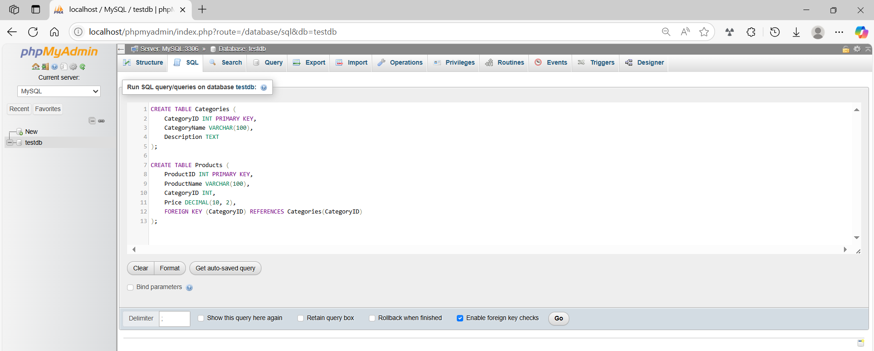
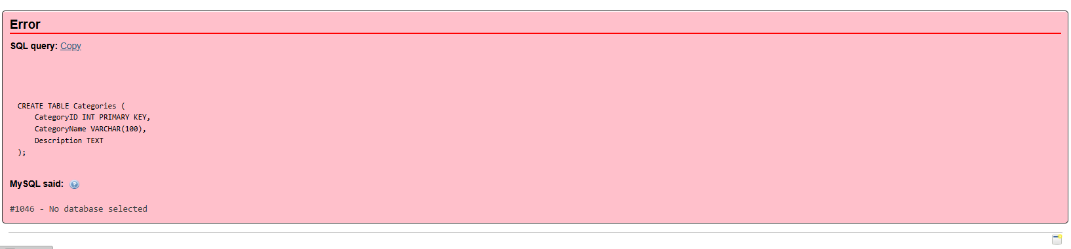
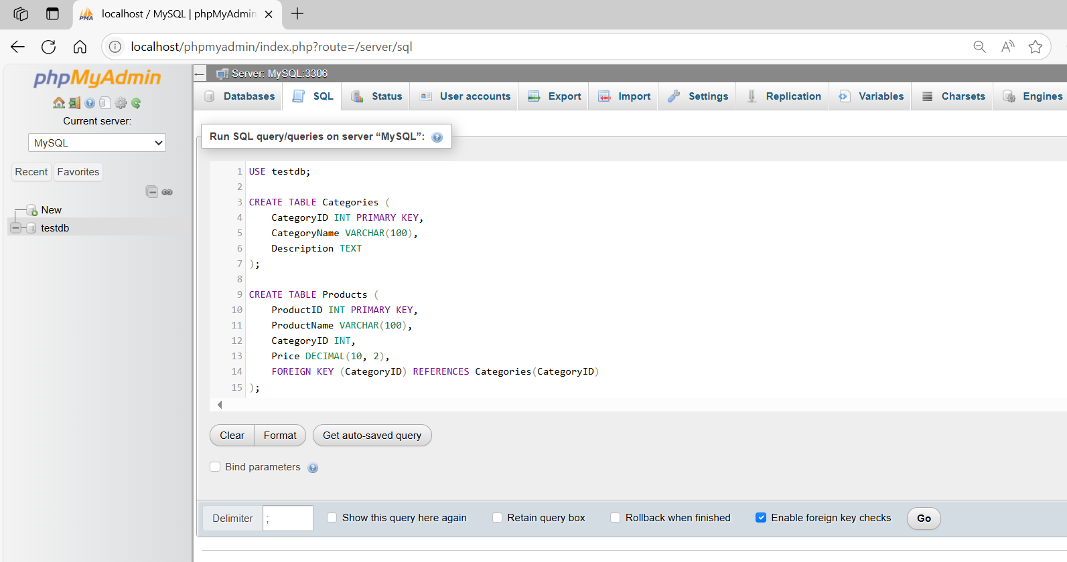
USE testdb;

CREATE TABLE Categories (
CategoryID INT PRIMARY KEY,
CategoryName VARCHAR(100),
Description TEXT
);

CREATE TABLE Products (
ProductID INT PRIMARY KEY,
ProductName VARCHAR(100),
CategoryID INT,
Price DECIMAL(10, 2),
FOREIGN KEY (CategoryID) REFERENCES Categories(CategoryID)
);

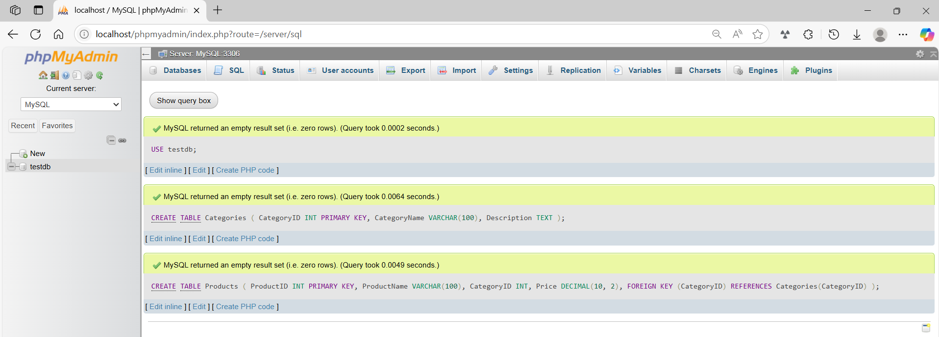
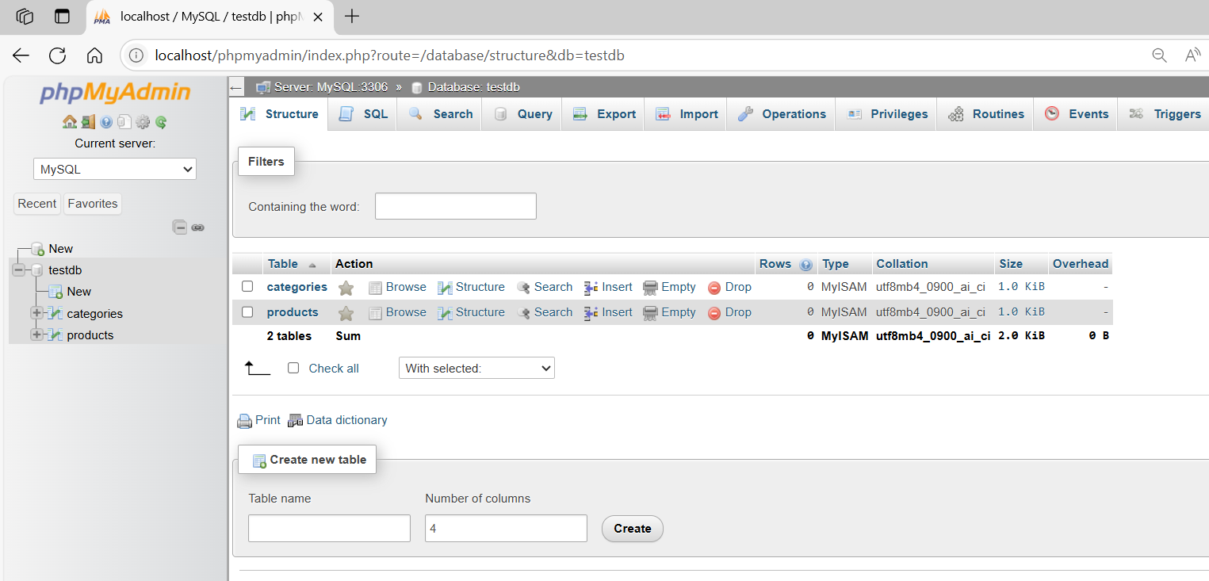

basic command - SHOW DATABASES
# Source: ScreenShot Source: Provided by: [Persons Table -> ID Column: 1, Name_En Column: Motasem Essam] -> Tool: [Automation Table -> ID Column: 16, Name_En Column: Screen Capture] -> From [Operating System: Wampserver64 -> phpmyadmin] on [6/11/2026]
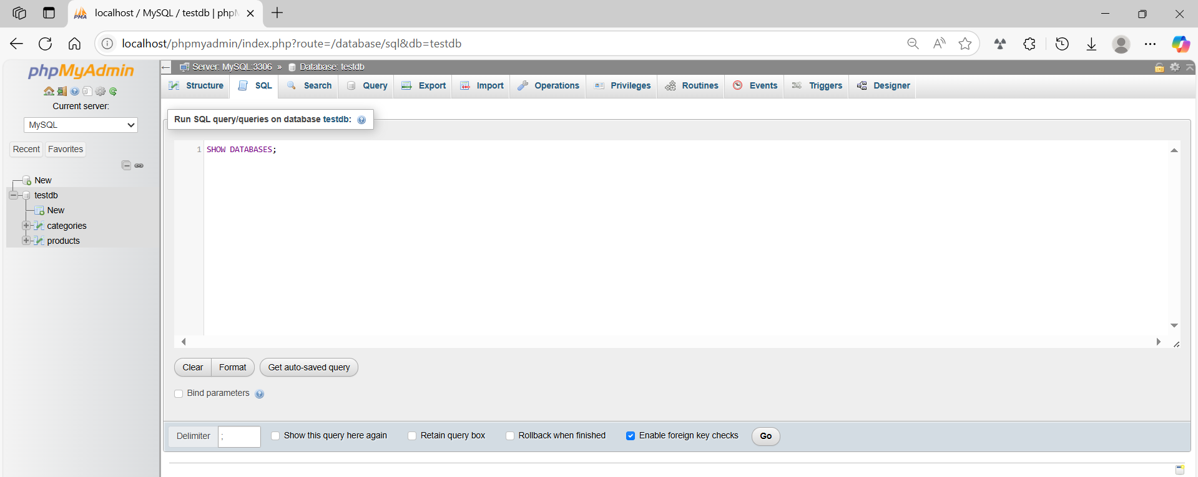
SHOW DATABASES;
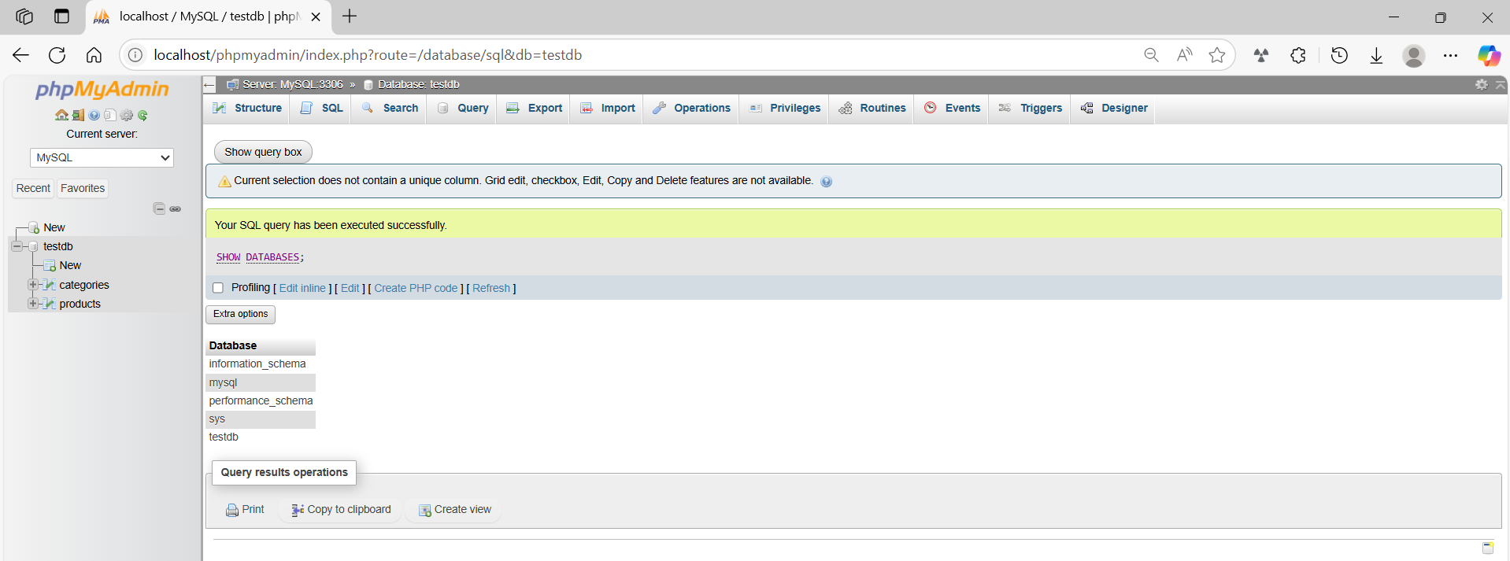

basic command - SHOW TABLES
# Source: ScreenShot Source: Provided by: [Persons Table -> ID Column: 1, Name_En Column: Motasem Essam] -> Tool: [Automation Table -> ID Column: 16, Name_En Column: Screen Capture] -> From [Operating System: Wampserver64 -> phpmyadmin] on [6/11/2026]
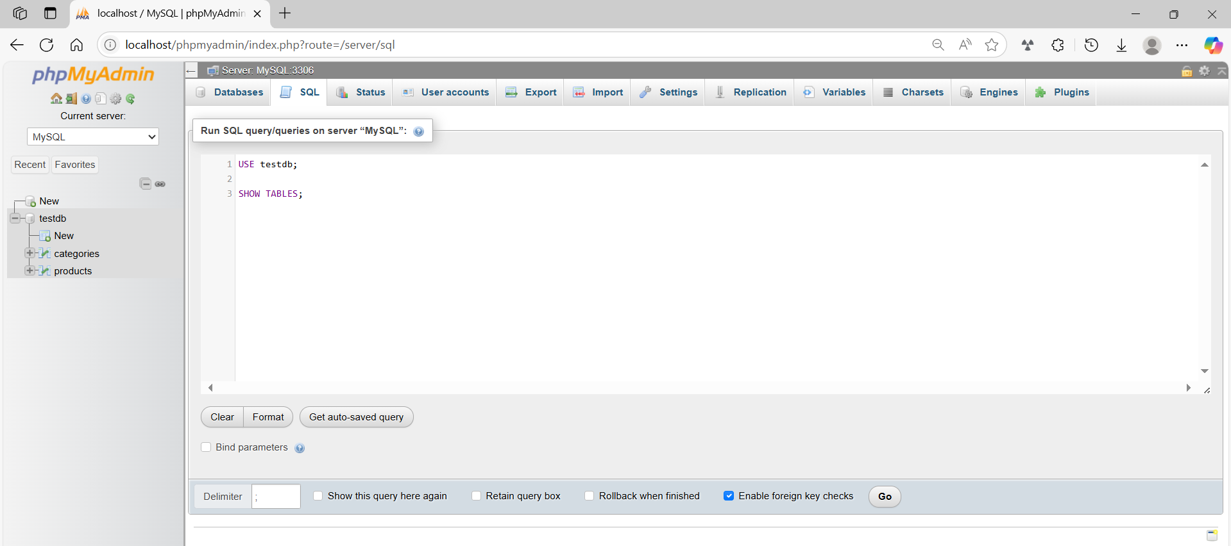
USE testdb;

SHOW TABLES;
